# Automation Test Store E2E Test Plan

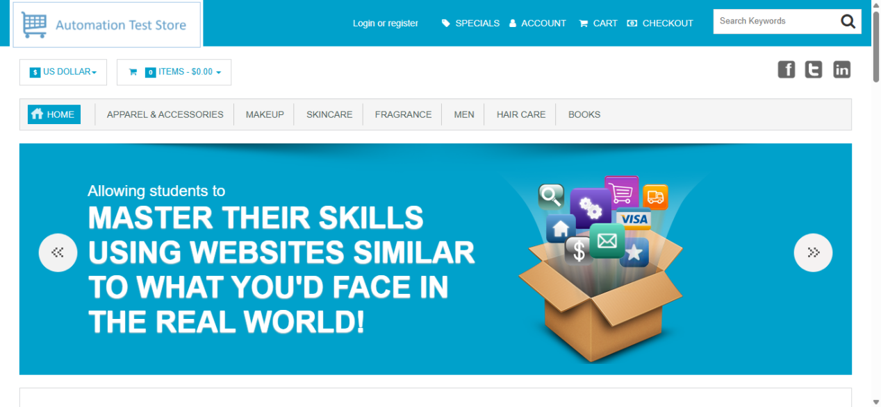

#### Done By

#### Abdullah Aladham

Automation Test Store Test Plan 1

Introduction 3

# Introduction

This testing plan is for Automation Test Store , Which is a demo Store that simulates a real world E-commerce store,This testing aims to ensure that the web application meets the requirements and free from defects.

# Test Objective(s)

The E2E Test Should validate from requirements perspective and business perspective that:

* All Cart Functions are working correctly.
* All Checkout Functions are working correctly.
* User membership Functions are working correctly.
* Products with all statuses are working correctly.
  + Product categories are working correctly.
* Search functions and or types are working correctly.
* Order Details functions are working correctly.
* Subscribe to newsletter function is working correctly.

# Test Scope

The E